

**AMERICAN INTERNATIONAL UNIVERSITY–BANGLADESH (AIUB)**

**FACULTY OF SCIENCE & TECHNOLOGY**

**DEPARTMENT OF PHYSICS**

**PHYSICS LAB 1**

**Summer 2020-2021**

**Section: J, Group: 6**

**LAB REPORT 5:**

***To determine the temperature coefficient of resistance of the material of a wire.***

**Supervised By**

**BITHI PAUL**

**Submitted By**

|  |  |  |
| --- | --- | --- |
| ***Name*** | ***ID*** | ***Contribution*** |
| Ahmed Farhan Amin | 21-44804-1 |  |
| Nokibul Arfin Siam | 21-44793-1 |  |
| G.M. Alvi Siddique | 20-43659-2 |  |
| Shayakh Al Araf Slowk | 21-44591-1 |  |
| M.A.R.M Sourav | 20-43659-2 |  |

Date of Submission: **July 10, 2021**

**TABLE OF CONTENTS**

|  |  |
| --- | --- |
| ***TOPICS*** | ***Page No.*** |
| 1. **Title Page** |  |
| 1. **Table of Content** |  |
| 1. **Theory** |  |
| 1. **Equipment** |  |
| 1. **Procedure** |  |
| 1. **Experimental Data** |  |
| 1. **Calculation** |  |
| 1. **Result** |  |
| 1. **Resources** |  |
|  |  |

**Theory**

Temperature coefficient of resistance is the property of the material of a substance. It is the measure of change in electrical resistance of any substance per degree of temperature change.

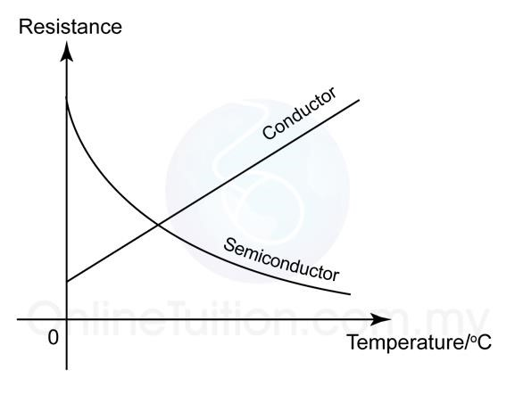

Figure 5.1: A graph that shows the changes in resistances of a conductor and a semiconductor with temperature. For conductor the resistance increases linearly and for semiconductor the resistance decreases exponentially with the temperature.

For a conductor the resistance increases with increase of temperature, as the figure 5.1 shows. If R1 is the resistance of a conductor at temperature θ1 and at a higher temperature θ2 the resistance raises to R2, then we can write

𝑅2 = 𝑅1[1 + 𝛼 (𝜃2 − 𝜃1)], (1)

where 𝛼 is the temperature coefficient of the material of the conductor.

Rearranging Eq. 1, we get

𝑅2 = 𝑅1 + 𝛼𝑅1(𝜃2 − 𝜃1)

=> 𝛼𝑅1(𝜃2 − 𝜃1) = 𝑅2 − 𝑅1

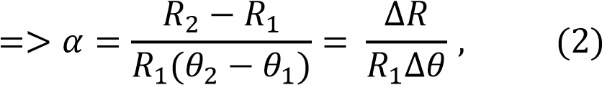

where ∆𝑅 (= 𝑅2 − 𝑅1) is the change in resistance due to the change in temperature ∆𝜃(= 𝜃2 −

𝜃1).

In Eq. (2) if we put R1 = 1 Ohm and ∆𝜃 = 1 0C we get 𝛼 = ∆𝑅, thus we define the temperature coefficient of resistance of a substance as the change in resistance per unit resistance (per ohm) for unit change in temperature (per 0C). Also, we find the unit of 𝛼 as per 0C.

For a conductor, if we know the resistances R1 at a temperature θ1 and R2 at a higher temperature θ2 , then we can calculate the temperature coefficient of resistance of its material by using the Eq. 2. The unknown resistance can be determined by a meter bridge that works with the Wheatstone bridge principle.

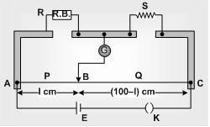

**D**

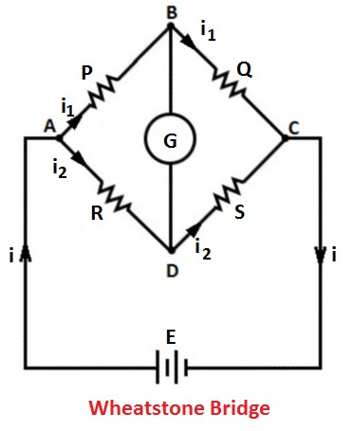

**X**

**X**

Figure 5.2: A meter bridge can be used to determine an unknown resistance by using the Wheatstone bridge principle.

In the meter bridge circuit as in fig. 5.2, for the null deflection in the galvanometer we get

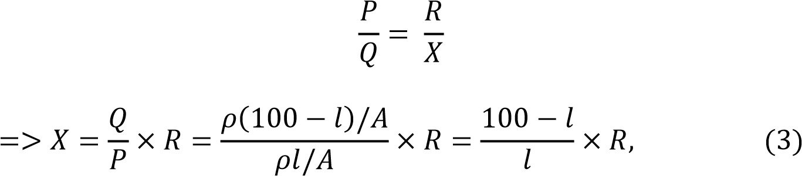

where 𝜌 is the specific resistance of the material and A is the cross-sectional area of the wire of the meter bridge.

According to Eq. (3) if we know the length of the balance point, l and the resistance, R we can determine the unknown resistance X.

**Equipment**

Power supply, meter bridge, galvanometer, jockey, resistance box, coil of conducting wire, commutator, thermometer, Beeker, water, electric heater, etc.

**Procedure**

**Experimental Data**

|  |  |  |  |  |  |  |  |  |
| --- | --- | --- | --- | --- | --- | --- | --- | --- |
| Temperature    (  0  C  ) | Known  resistance    R    (Ohms) | Position of unknown resistance    X | Position of Balance point, *l* (cm) | | Mean  *l*    (cm) | 100 – *l*        (cm) | X    (Ohms) | Mean    X    (Ohms) |
| Direct current | Reverse current |
| θ    1    =    24 | 5 | Left | 58.2 | 59.1 | 58.65 | 41.35 | 7.09 | **X1 =** 6.14 |
| Right | 49.5 | 50.5 | 50 | 50 | 5 |
| 7 | Left | 22.5 | 51.9 | 37.2 | 62.8 | 4.15 |
| Right | 54.5 | 51.8 | 53.15 | 46.85 | 6 .17 |
| 9 | Left | 47.3 | 45.5 | 46.4 | 53.6 | 7.79 |
| Right | 59.3 | 55.9 | 57.6 | 42.4 | 6.63 |
| θ    2      =    80 | 5 | Left | 58.1 | 56.1 | 57.1 | 42.9 | 6.66 | **X2 =** 7.66 |
| Right | 44.5 | 40.2 | 42.35 | 57.65 | 6.81 |
| 7 | Left | 56.9 | 50.7 | 53.8 | 46.2 | 8.15 |
| Right | 46.7 | 49.6 | 48.15 | 51.85 | 7.54 |
| 9 | Left | 54.3 | 45.4 | 49.85 | 50.15 | 8.95 |
| Right | 52.6 | 54.1 | 53.35 | 46.65 | 7.87 |

**Calculation**

1. For left gap: $X=\frac{l}{100-l}×R$
2. For right gap: $X=\frac{100-l}{l}×R$
3. Temperature coefficient of resistance, $α=\frac{X_{2}-X_{1}}{X_{1}\left(θ_{2}-θ_{1}\right)}$

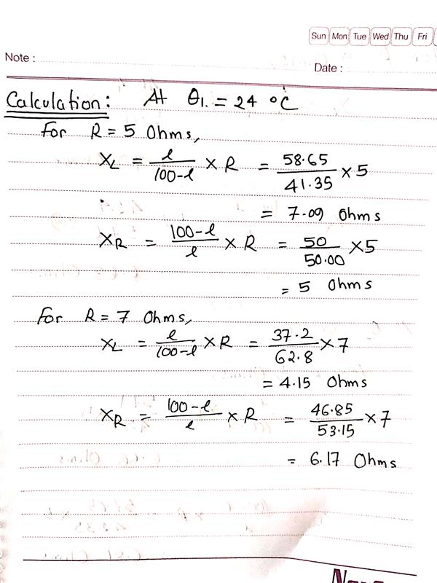

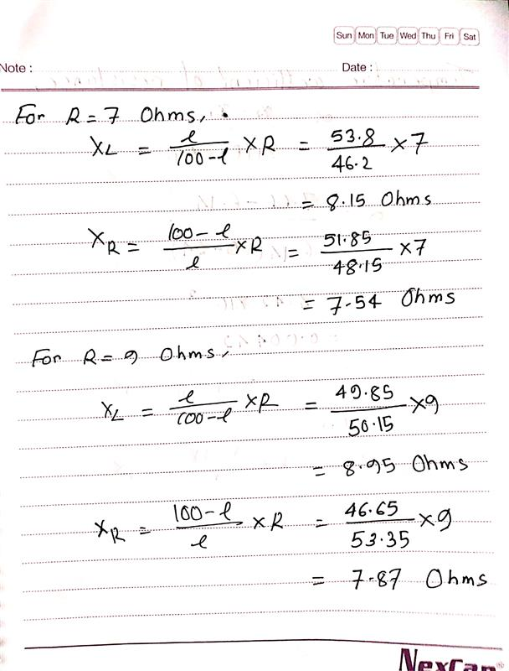

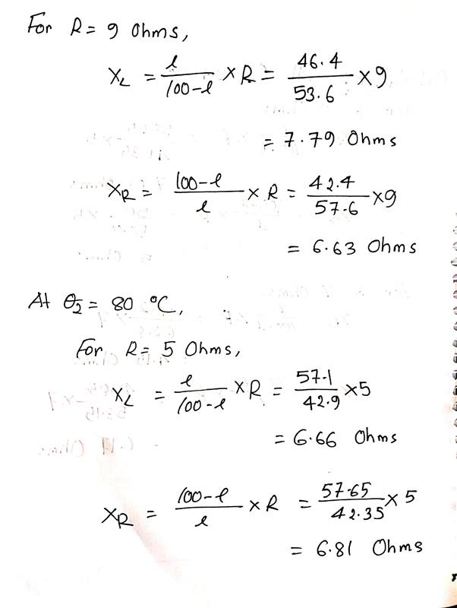

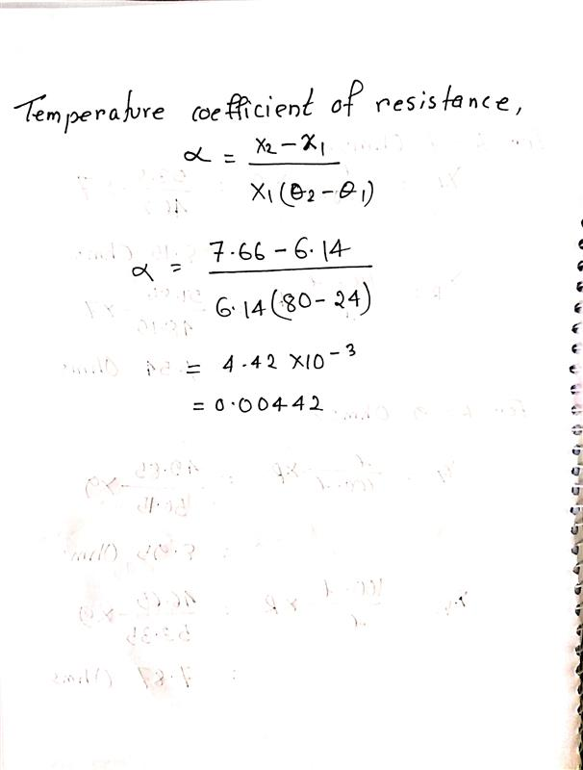

**Result**

|  |  |  |
| --- | --- | --- |
| **Temperature (0C)** | **Resistance (ohm)** | **Temperature coefficient of resistance (/0C)** |
|  |  | 0.00442 |
| $$θ_{2}=80$$ | $$X_{2}=7.66$$ |

**Resources**

Fundamental of Physics (*10th Edition*): Resistance and resistivity (*Chapter 26, page 755*)

Video Links:

Temperature coefficient: https://www.youtube.com/watch?v=TgmOfi2rn0s

Meter Bridge: https://www.youtube.com/watch?v=nqx8vIdHVkQ